Irregular Wavy Shapes

Definition
# Source: AI Source: Provided by: [Data Path: Persons Table -> ID Column: 1, Name_En Column: Motasem Essam] -> From: [ChatGPT] on [7/25/2026]
An Irregular Wavy Shape is a wavy shape whose boundary or path has a non-uniform, non-repeating, or inconsistent wave pattern.
Its waves may differ in:
- Amplitude
- Width
- Spacing
- Curvature
- Frequency
- Direction or orientation
Unlike a regular wavy shape, its wave features do not follow one consistent repeating pattern.
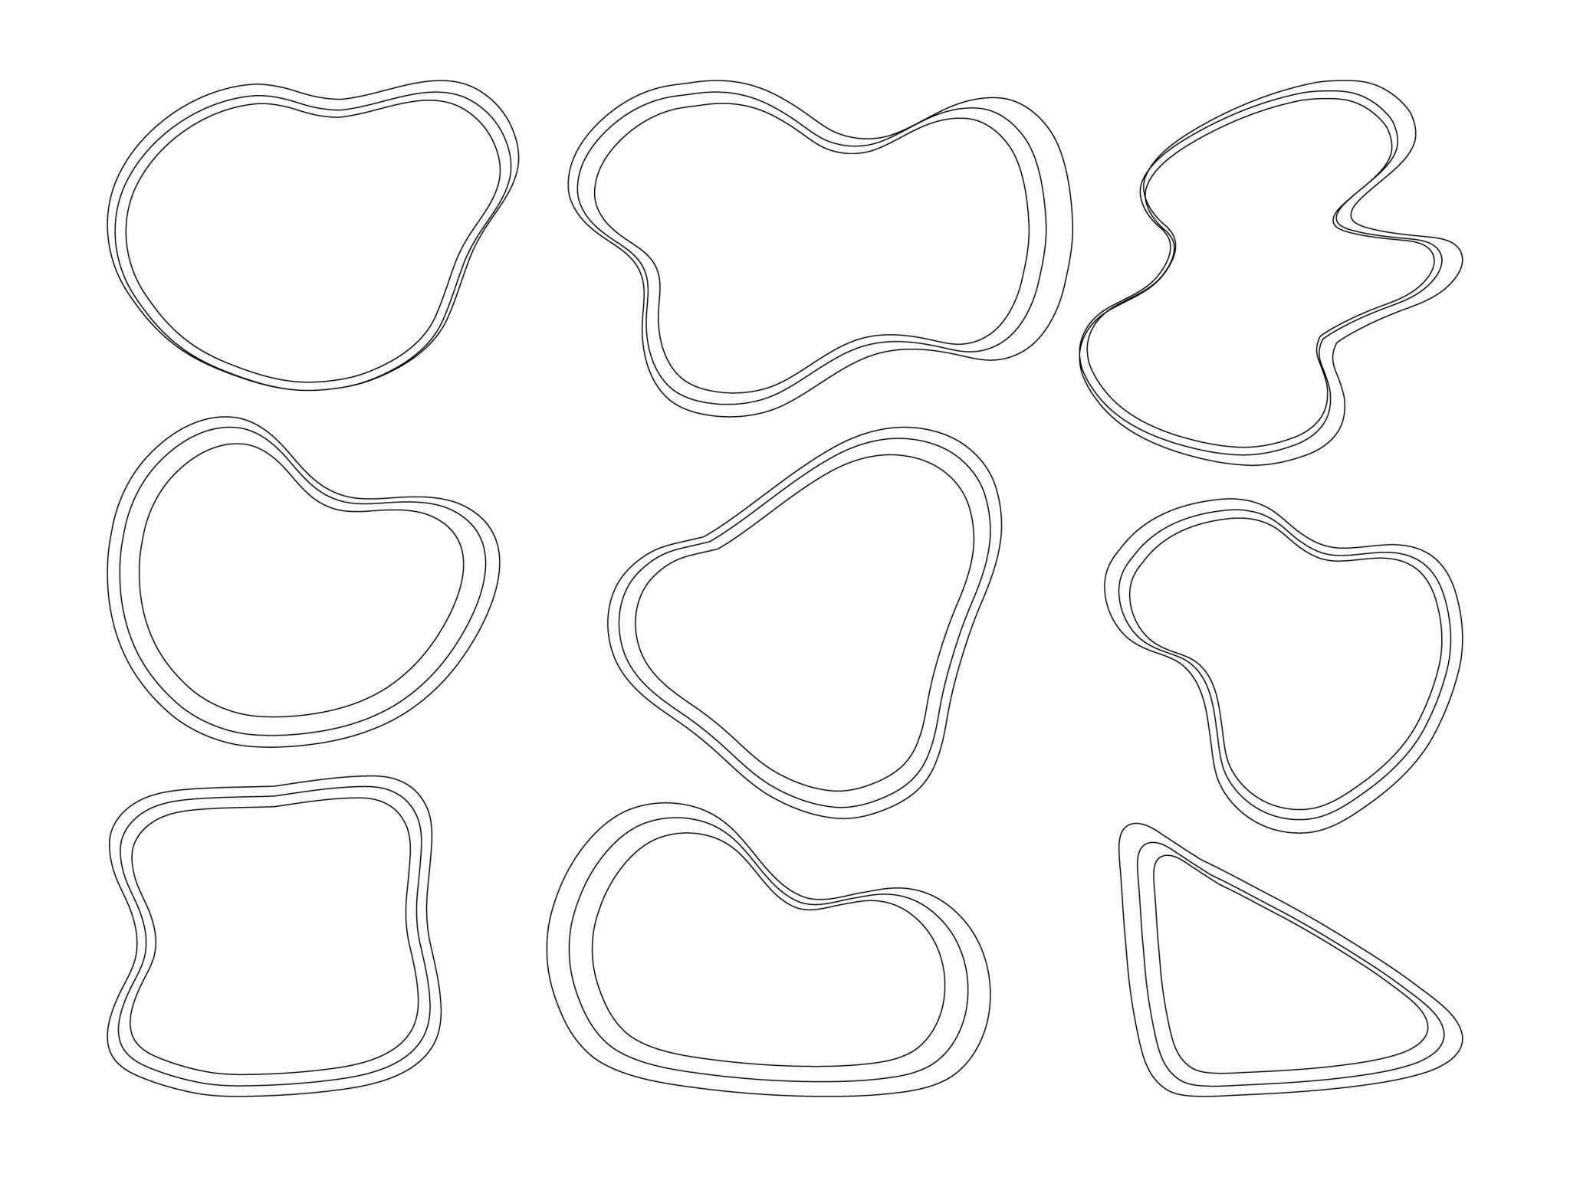
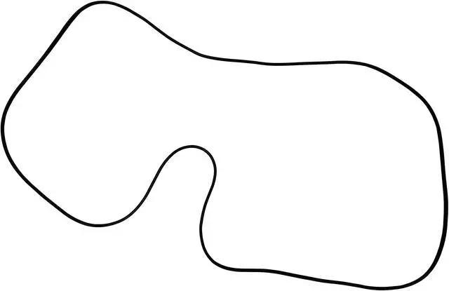
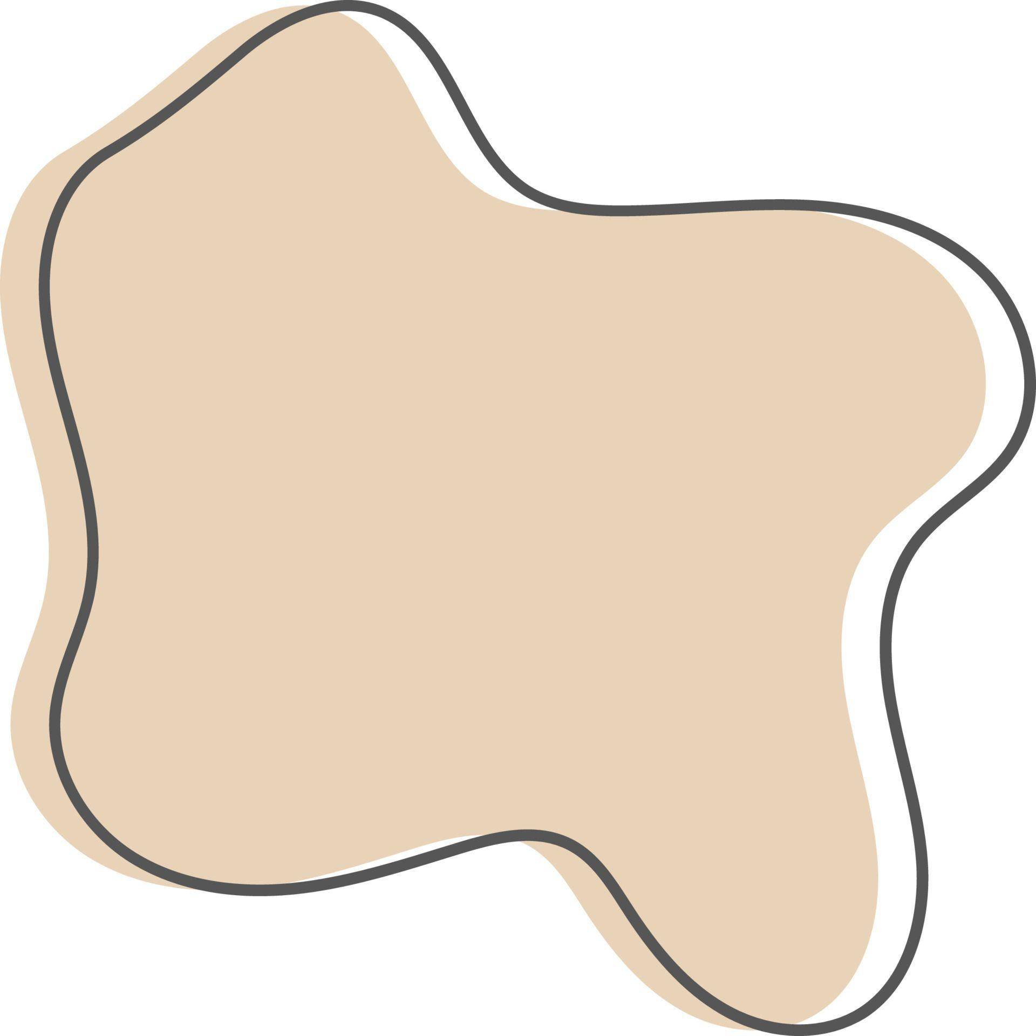
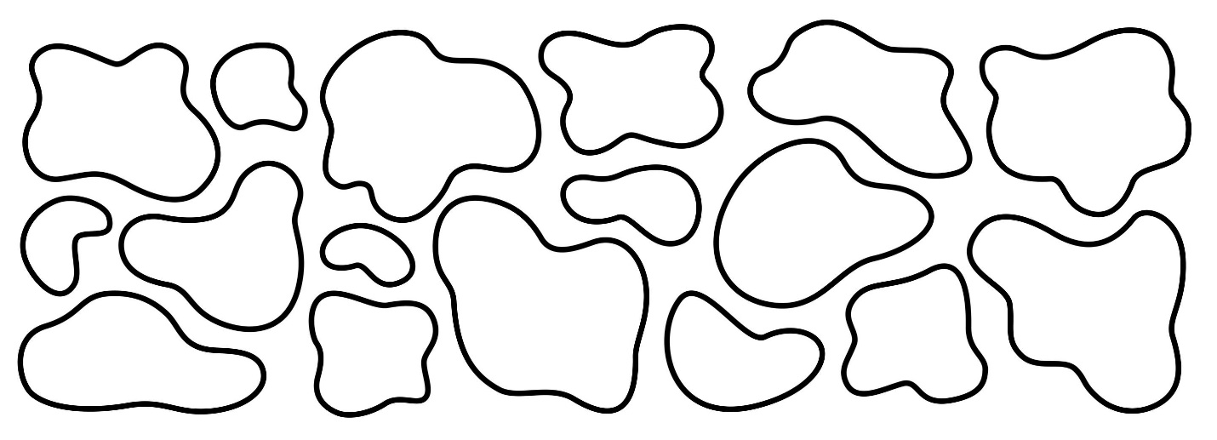
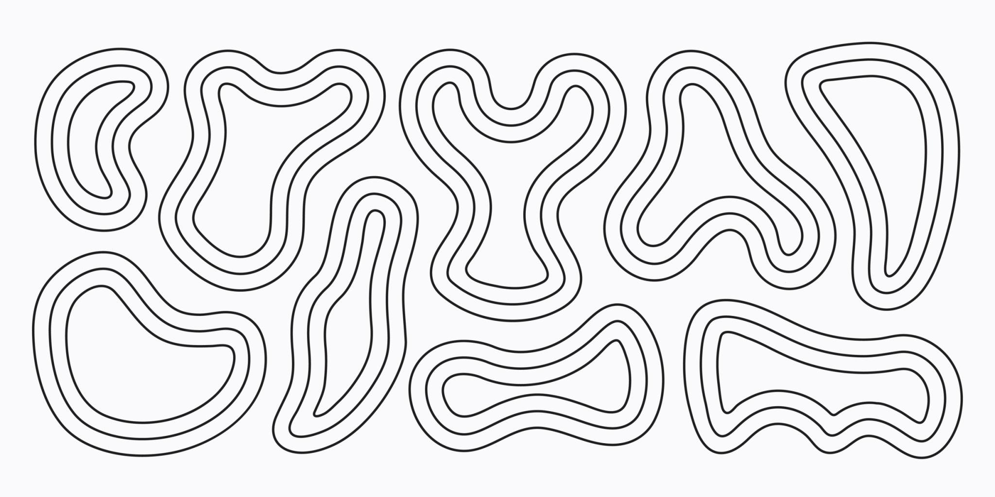

Fundamental Concept
# Source: AI Source: Provided by: [Data Path: Persons Table -> ID Column: 1, Name_En Column: Motasem Essam] -> From: [ChatGPT] on [7/25/2026]
The main characteristic of an irregular wavy shape is variation.
For example:
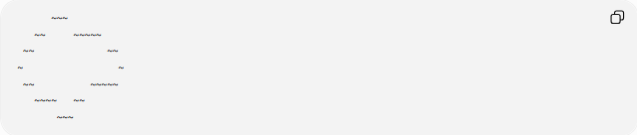
~~~
~~ ~~~~~
~~ ~~
~ ~
~~ ~~~~~
~~~~ ~~
~~~
The waves are not identical. Some may be larger, smaller, wider, narrower, or more tightly spaced than others.
Irregular describes the lack of uniformity; it does not necessarily mean the shape is asymmetric.

Main Characteristics
# Source: AI Source: Provided by: [Data Path: Persons Table -> ID Column: 1, Name_En Column: Motasem Essam] -> From: [ChatGPT] on [7/25/2026]
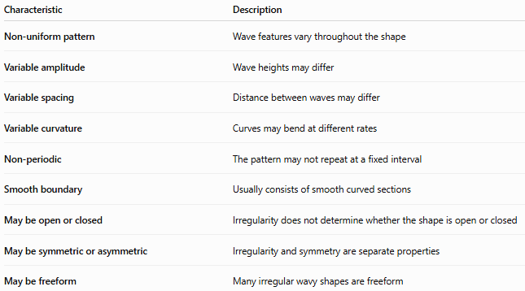
Characteristic | Description
Non-uniform pattern | Wave features vary throughout the shape
Variable amplitude | Wave heights may differ
Variable spacing | Distance between waves may differ
Variable curvature | Curves may bend at different rates
Non-periodic | The pattern may not repeat at a fixed interval
Smooth boundary | Usually consists of smooth curved sections
May be open or closed | Irregularity does not determine whether the shape is open or closed
May be symmetric or asymmetric | Irregularity and symmetry are separate properties
May be freeform | Many irregular wavy shapes are freeform

Basic Structure
# Source: AI Source: Provided by: [Data Path: Persons Table -> ID Column: 1, Name_En Column: Motasem Essam] -> From: [ChatGPT] on [7/25/2026]
An irregular wavy shape does not have to follow a simple equation such as
$$y=Asin⁡\left(Bx+C\right)+D$$
Instead, its boundary can be represented by a more general function:
$$y=f\left(x\right)$$
where $f\left(x\right)$may contain varying amplitudes, frequencies, or other changes.
A parametric representation can also be used:
$$r\left(t\right)=\left(x , \left(t\right)y\left(t\right)\right)$$
with no requirement that the curve repeat periodically.
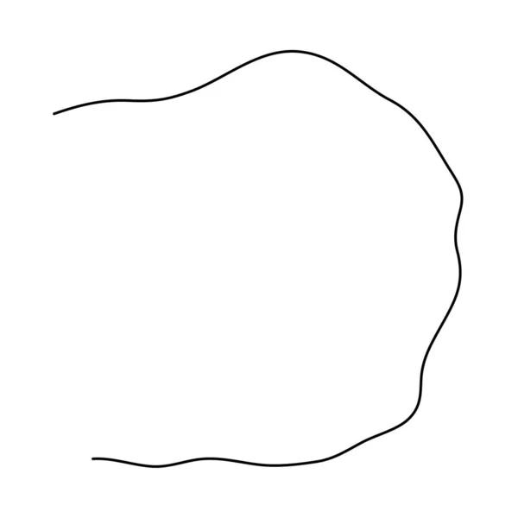
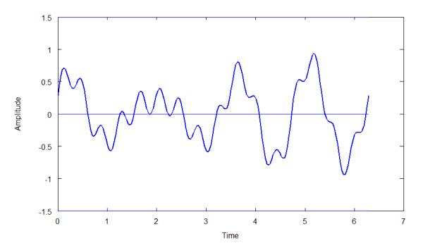
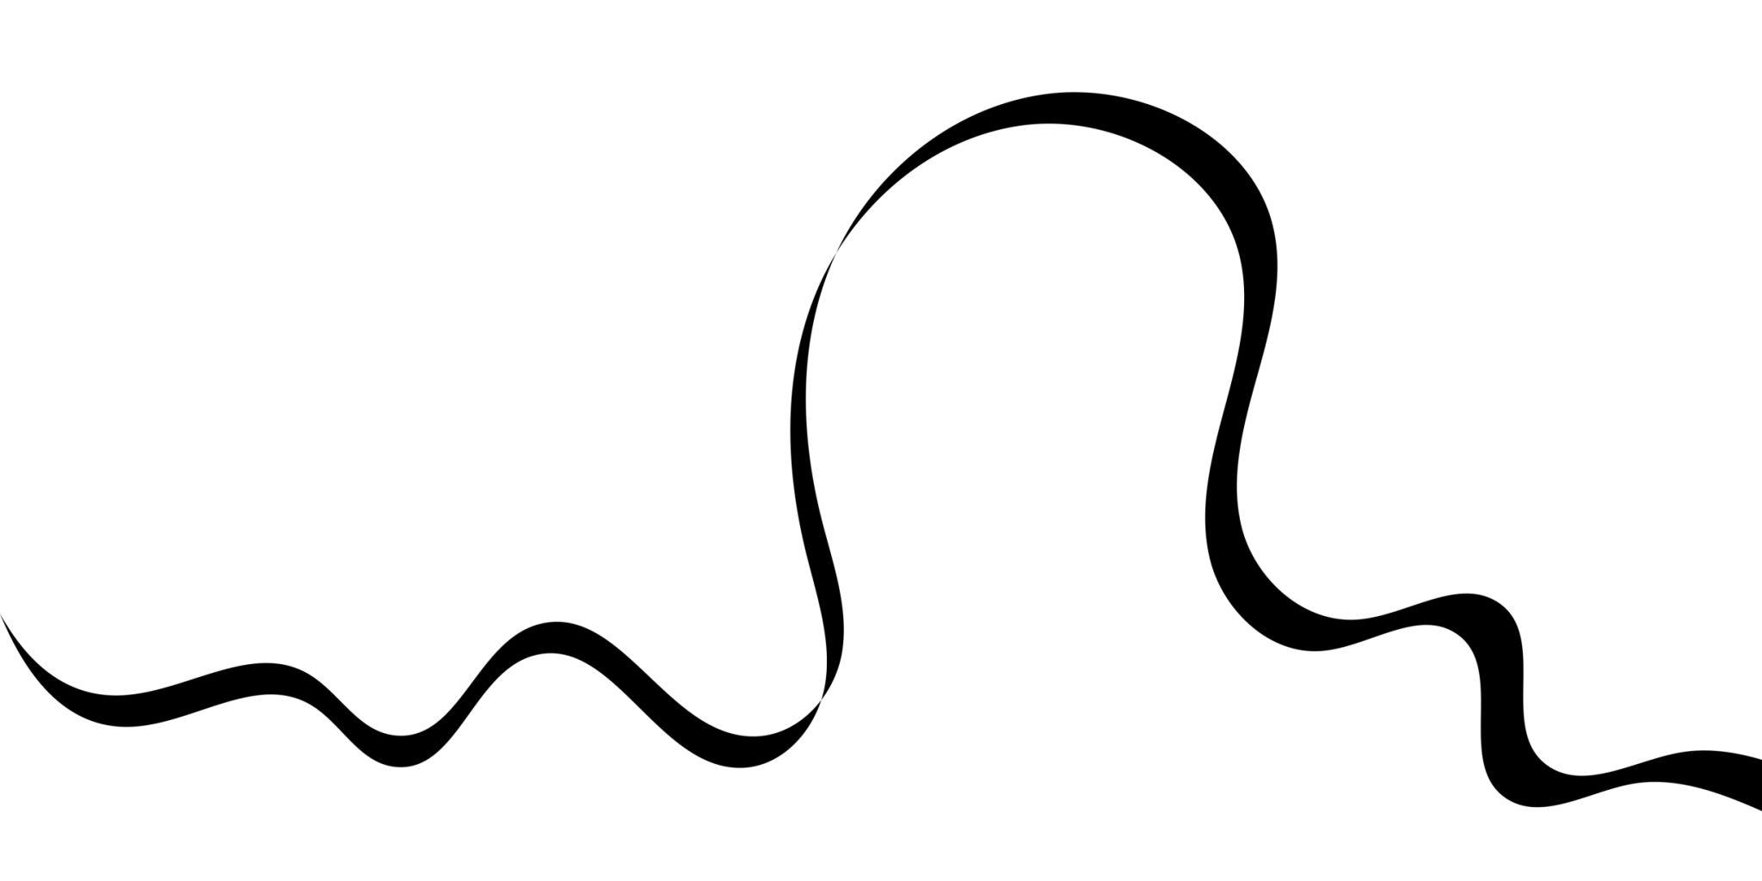
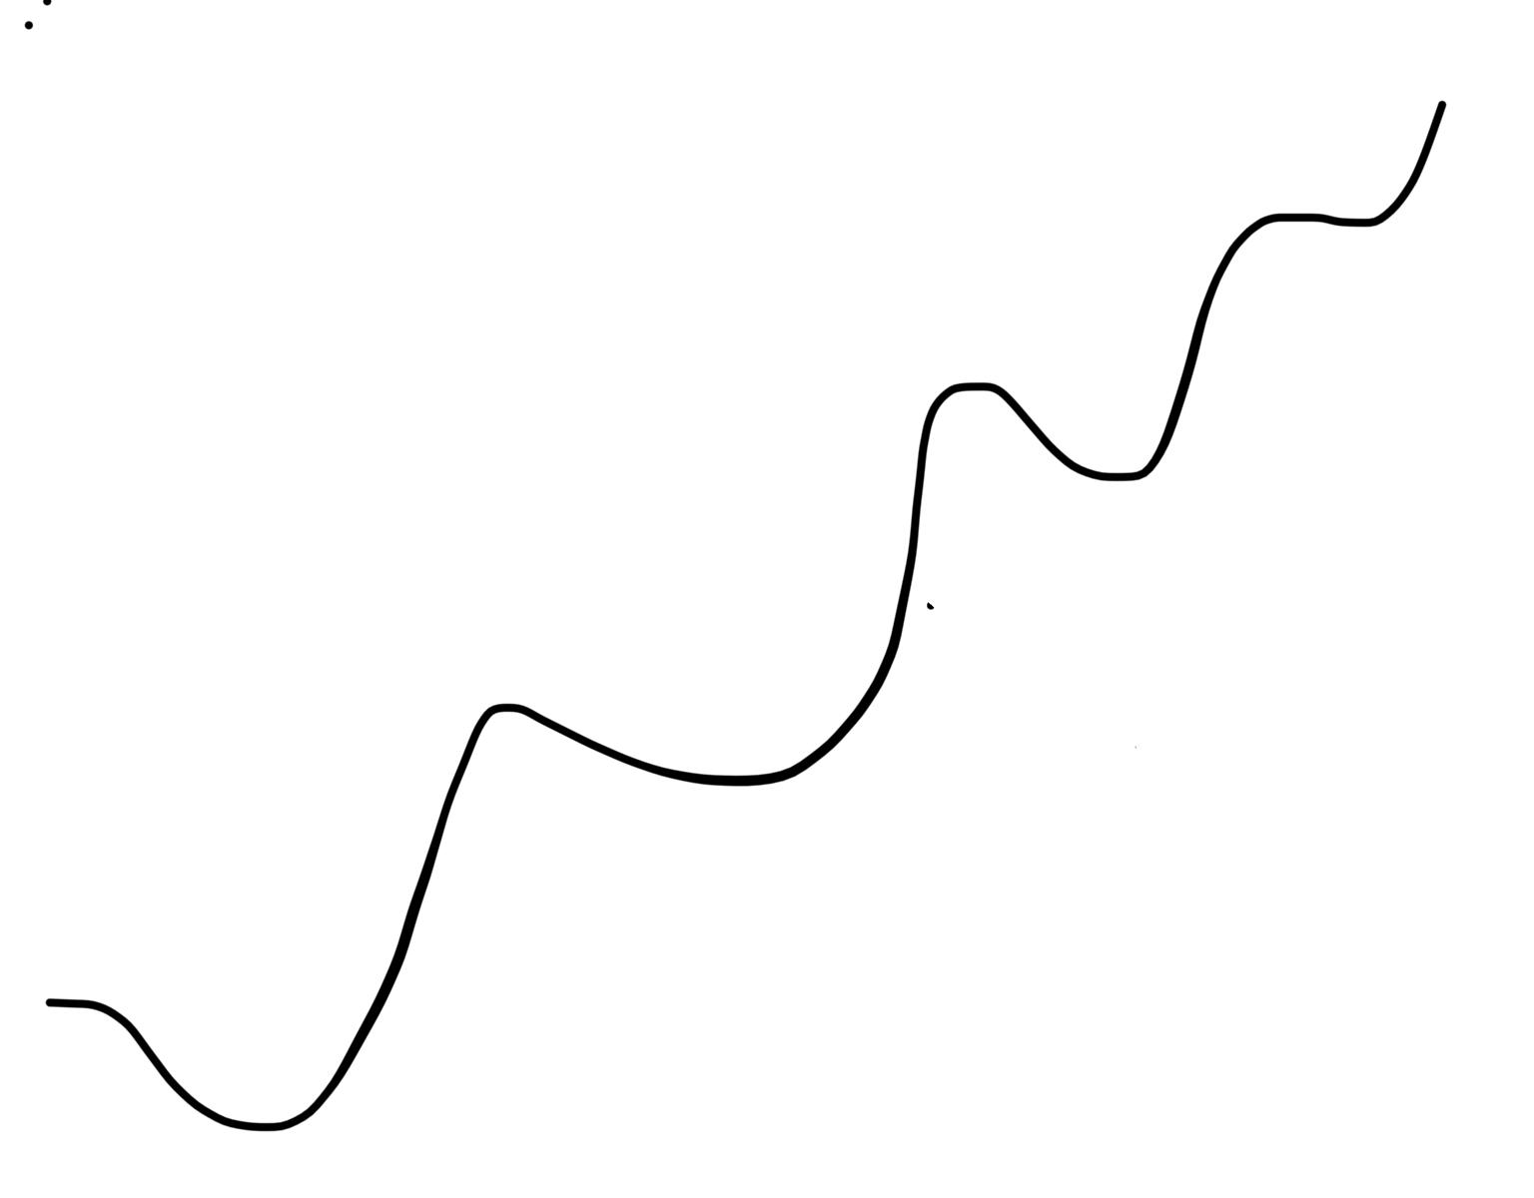
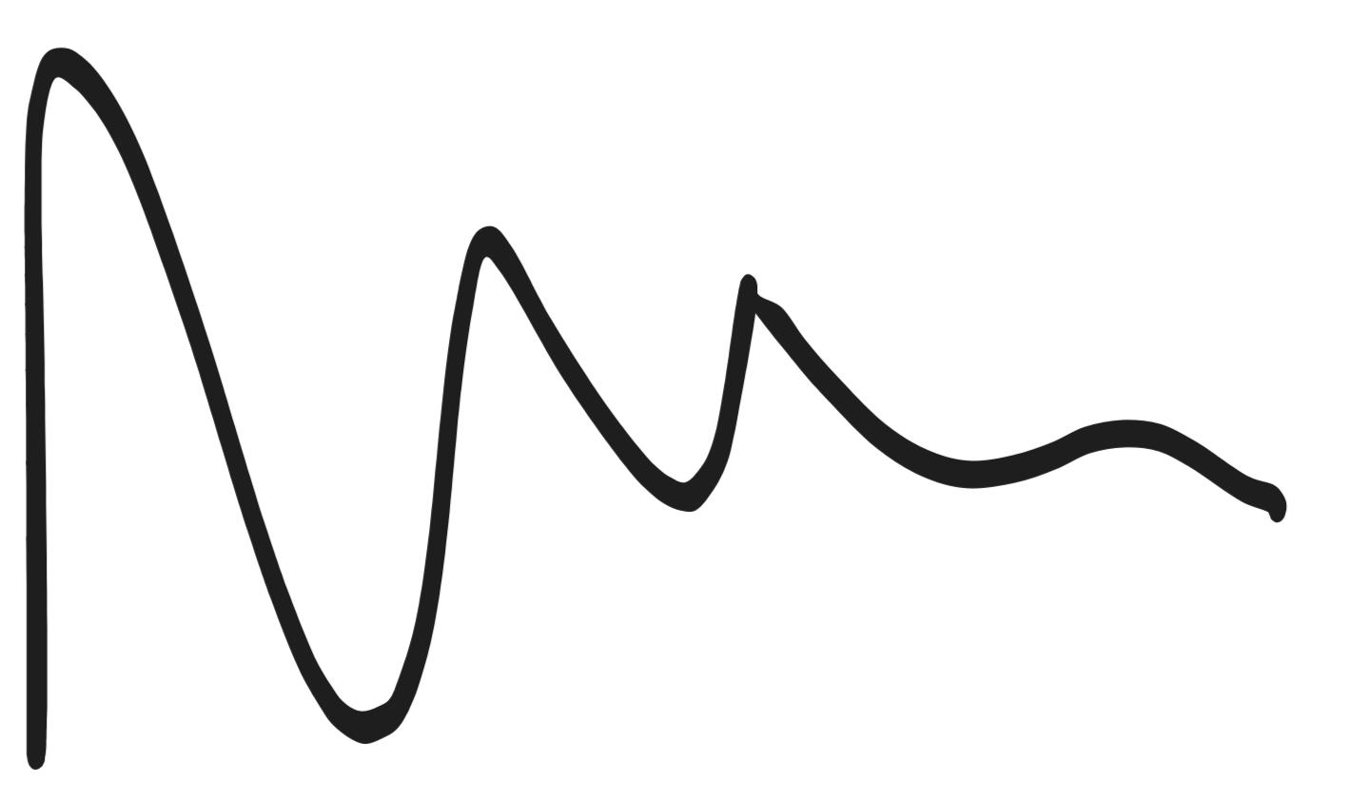

Types of Irregular Wavy Shapes
# Source: AI Source: Provided by: [Data Path: Persons Table -> ID Column: 1, Name_En Column: Motasem Essam] -> From: [ChatGPT] on [7/25/2026]
Irregular wavy shapes can be further described according to their structure.

1-Irregular Open Wavy Shapes
# Source: AI Source: Provided by: [Data Path: Persons Table -> ID Column: 1, Name_En Column: Motasem Essam] -> From: [ChatGPT] on [7/25/2026]
An Irregular Open Wavy Shape is an open curved path whose waves vary along its length.
It has:
- Two endpoints.
- No enclosed region by itself.
- Non-uniform waves.
Example:
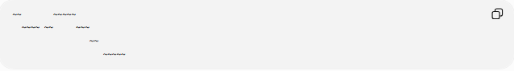
~~ ~~~~~
~~~~ ~~ ~~~
~~
~~~~~
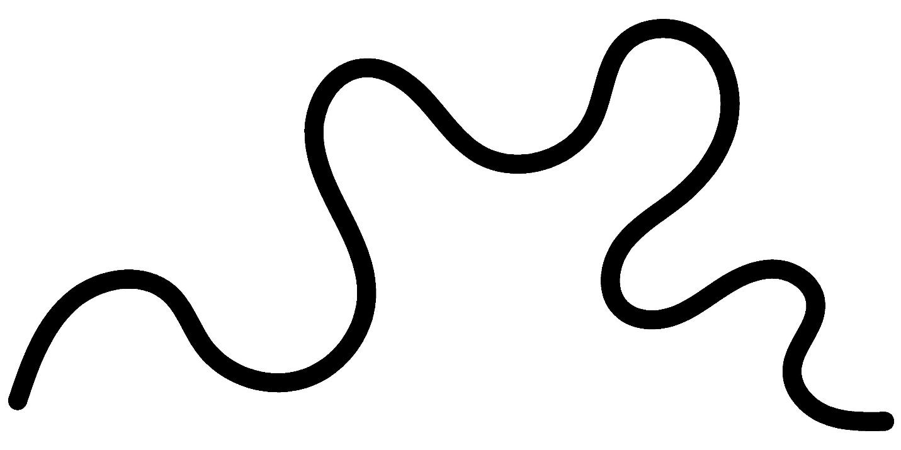
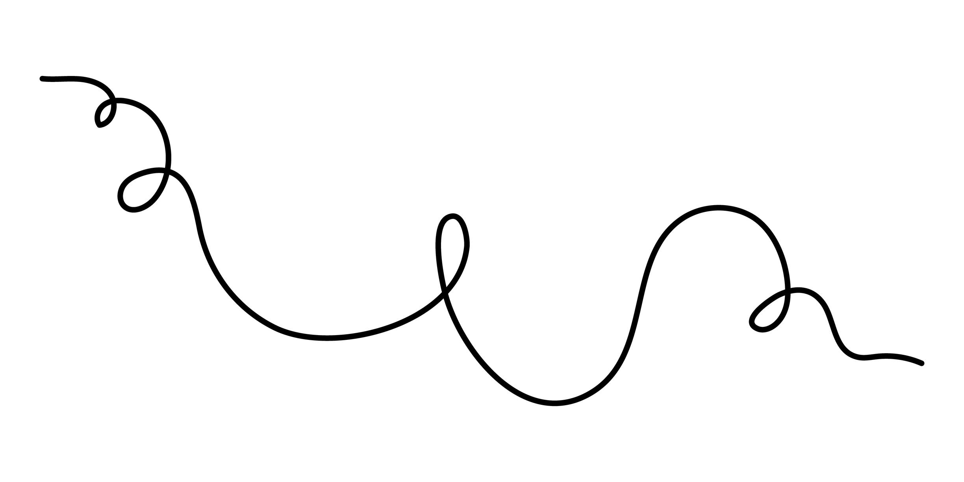
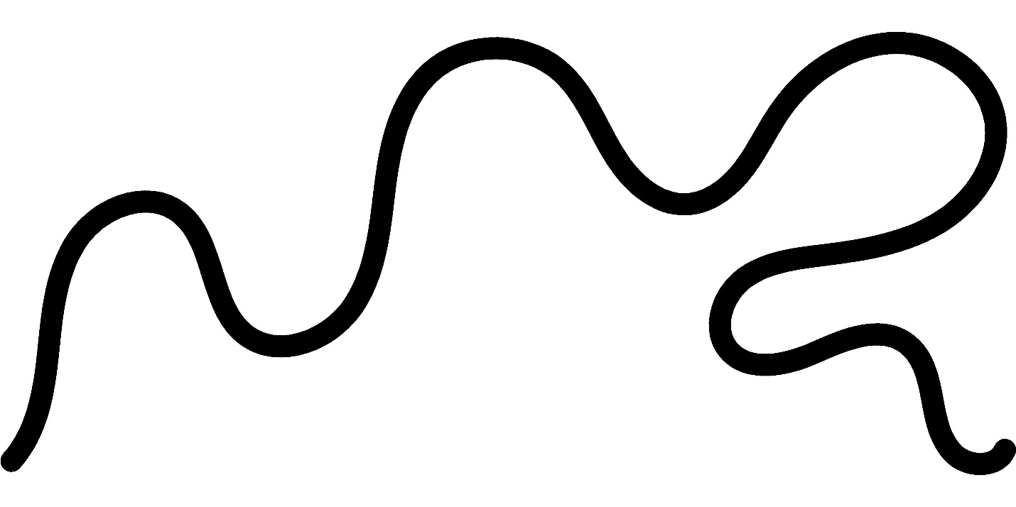
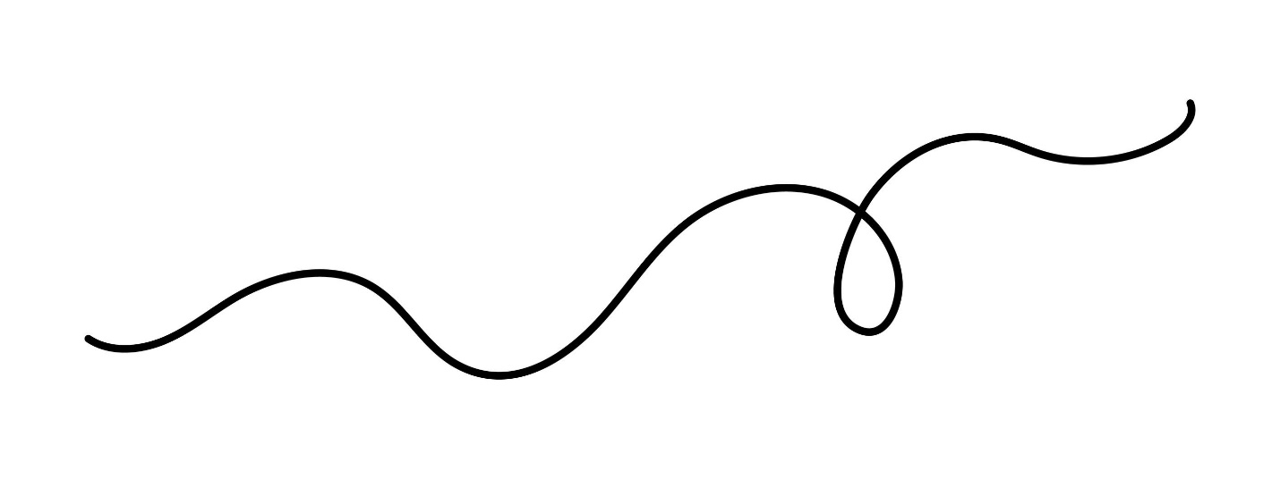
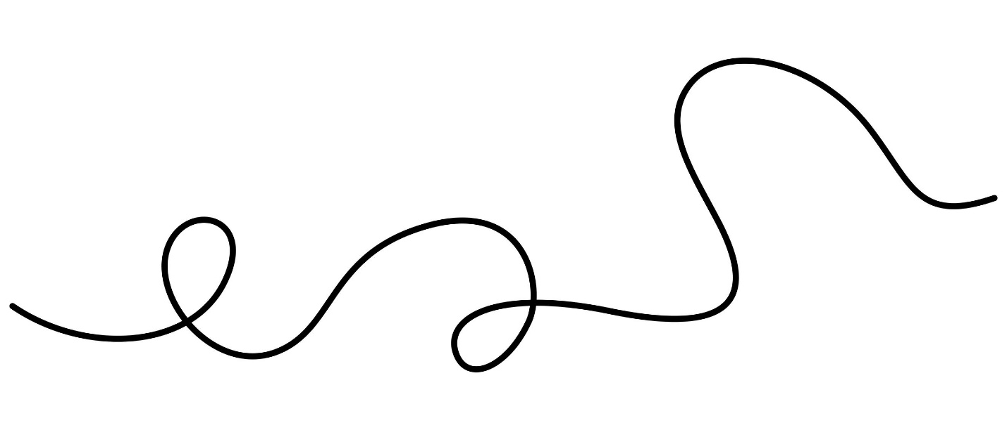

2-Irregular Closed Wavy Shapes
# Source: AI Source: Provided by: [Data Path: Persons Table -> ID Column: 1, Name_En Column: Motasem Essam] -> From: [ChatGPT] on [7/25/2026]
An Irregular Closed Wavy Shape has a continuous wavy boundary that returns to its starting point, while its wave pattern remains non-uniform.
It encloses a region.
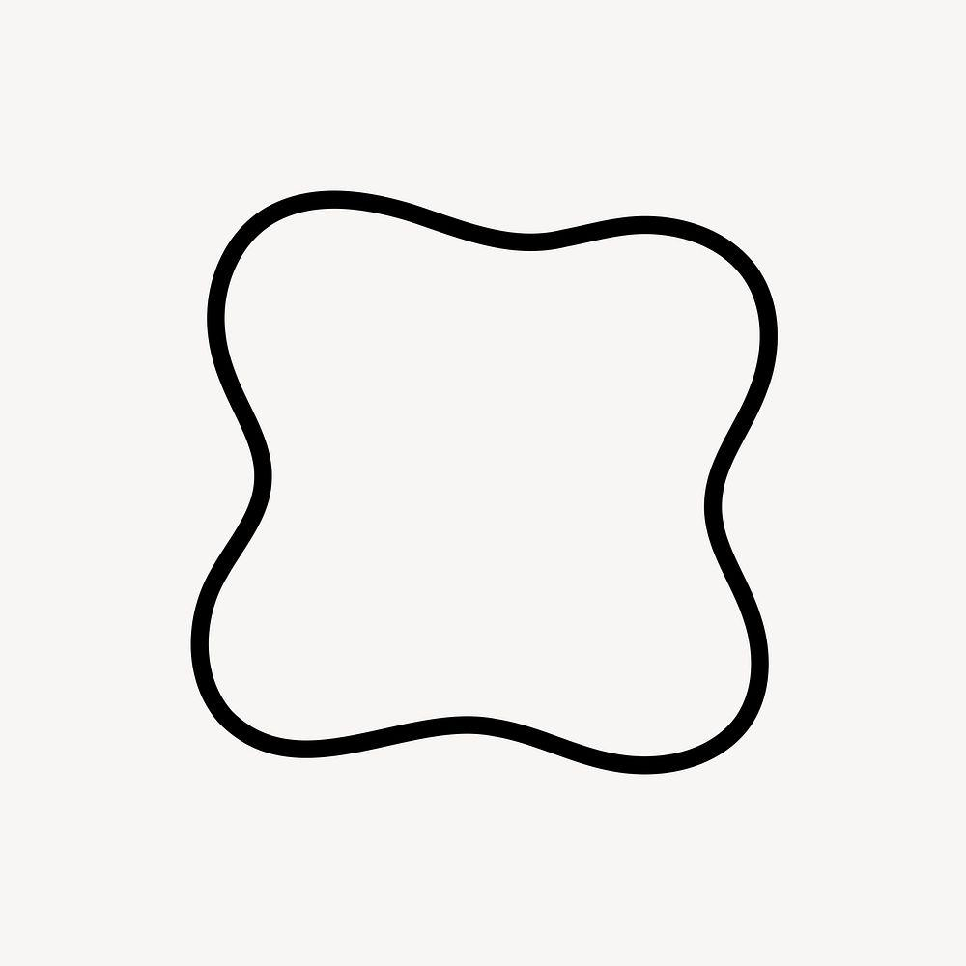
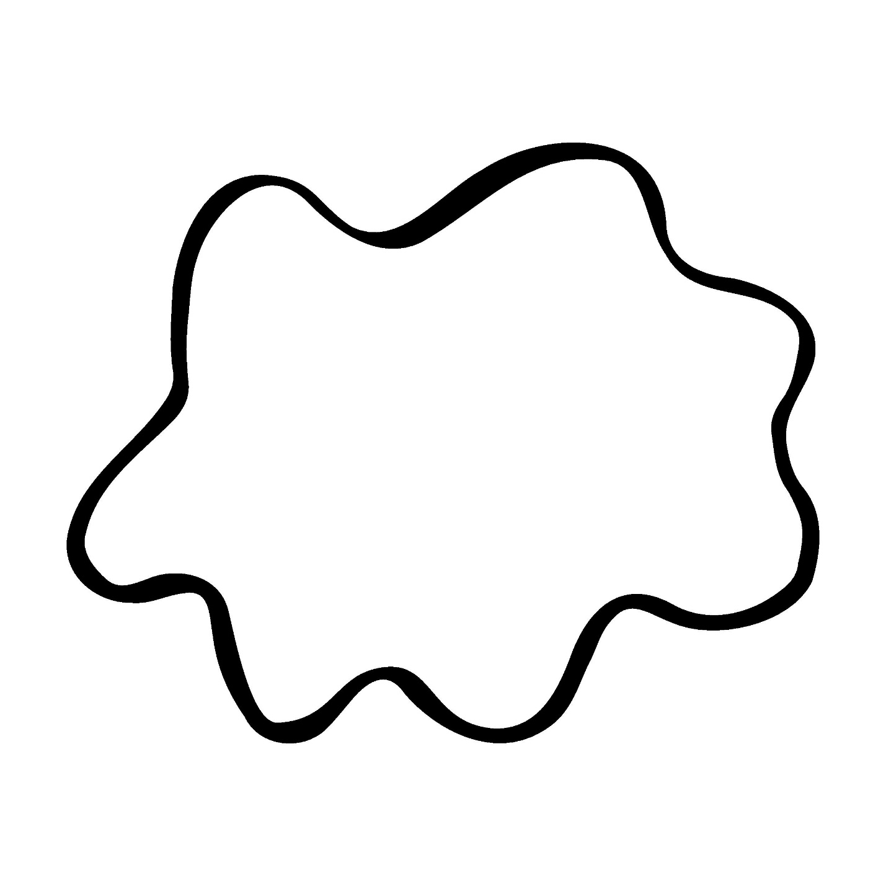
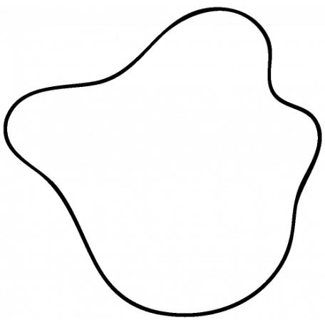
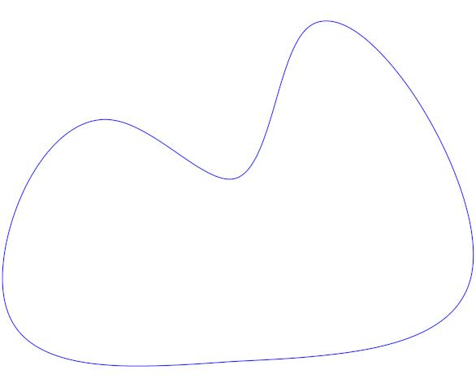

3-Irregular Symmetric Wavy Shapes
# Source: AI Source: Provided by: [Data Path: Persons Table -> ID Column: 1, Name_En Column: Motasem Essam] -> From: [ChatGPT] on [7/25/2026]
An irregular wavy shape can still possess symmetry.
For example, the left and right sides may be mirror images even though the individual waves are not all equal.
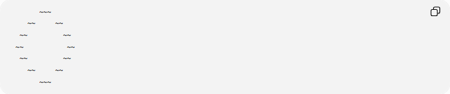
~~~
~~ ~~
~~ ~~
~~ ~~
~~ ~~
~~ ~~
~~~
Therefore:
Irregular does not necessarily mean asymmetric.
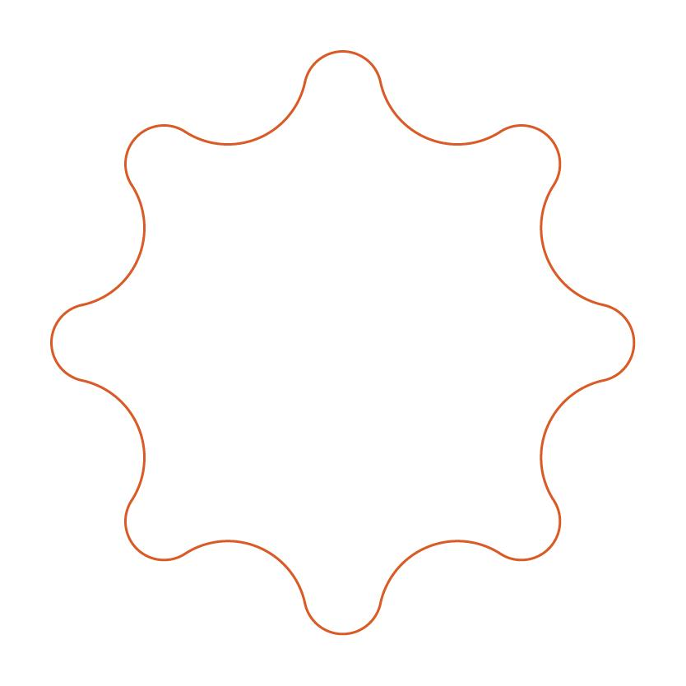
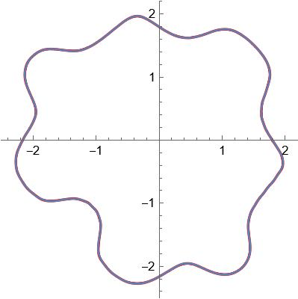
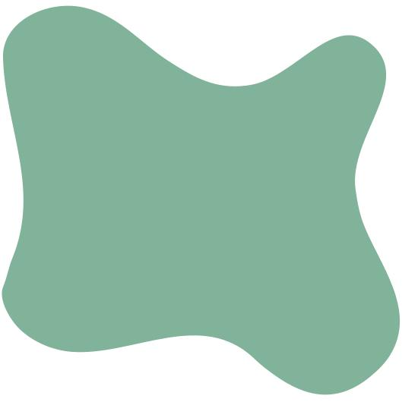
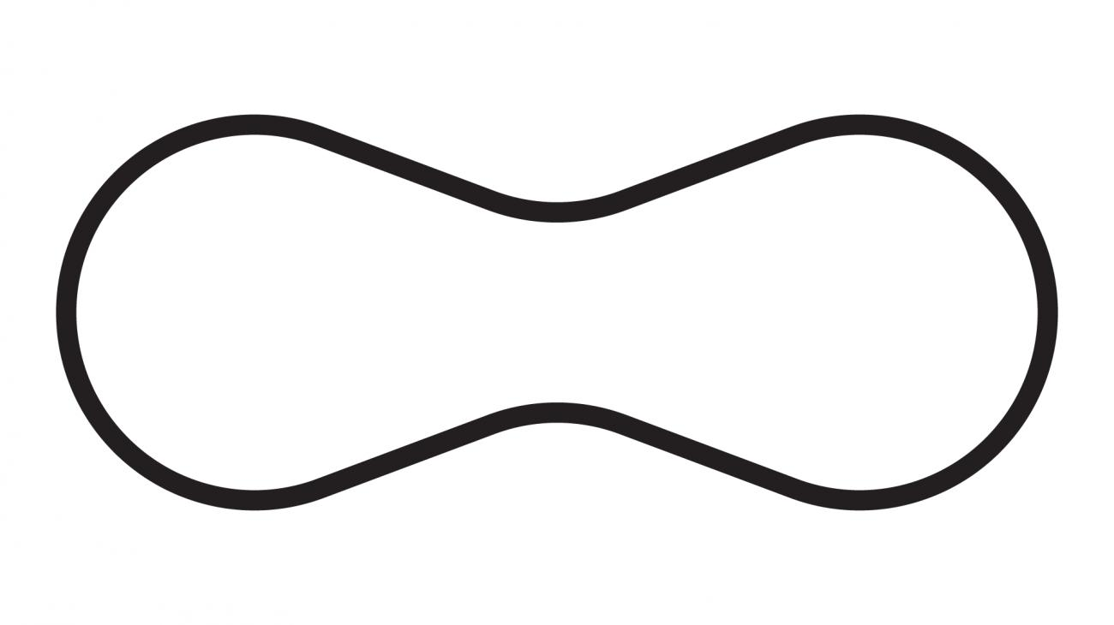

4-Irregular Asymmetric Wavy Shapes
# Source: AI Source: Provided by: [Data Path: Persons Table -> ID Column: 1, Name_En Column: Motasem Essam] -> From: [ChatGPT] on [7/25/2026]
An Irregular Asymmetric Wavy Shape has both:
- A non-uniform wave pattern.
- No relevant symmetry.
Different sections of the boundary may have substantially different wave sizes and curvature.
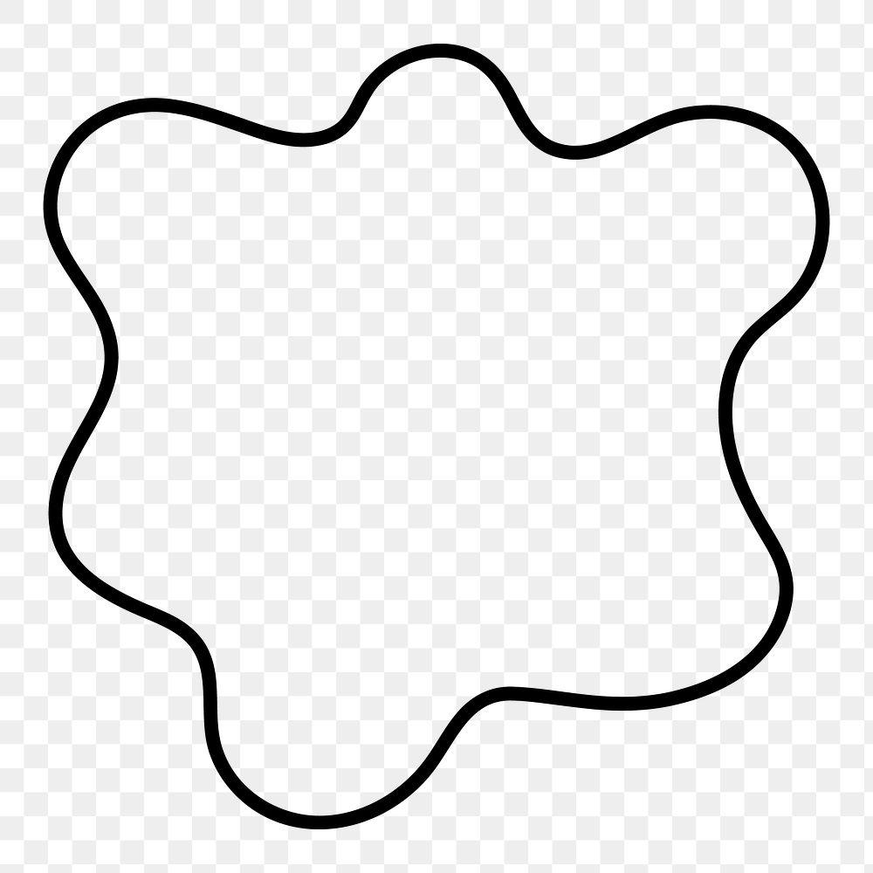
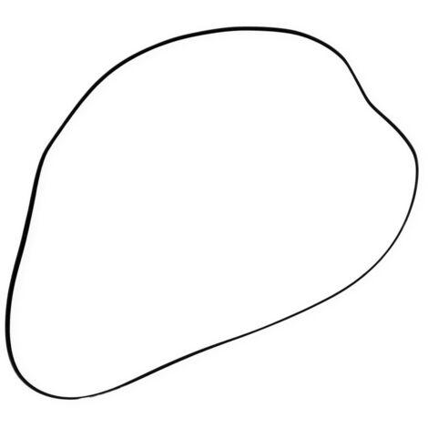
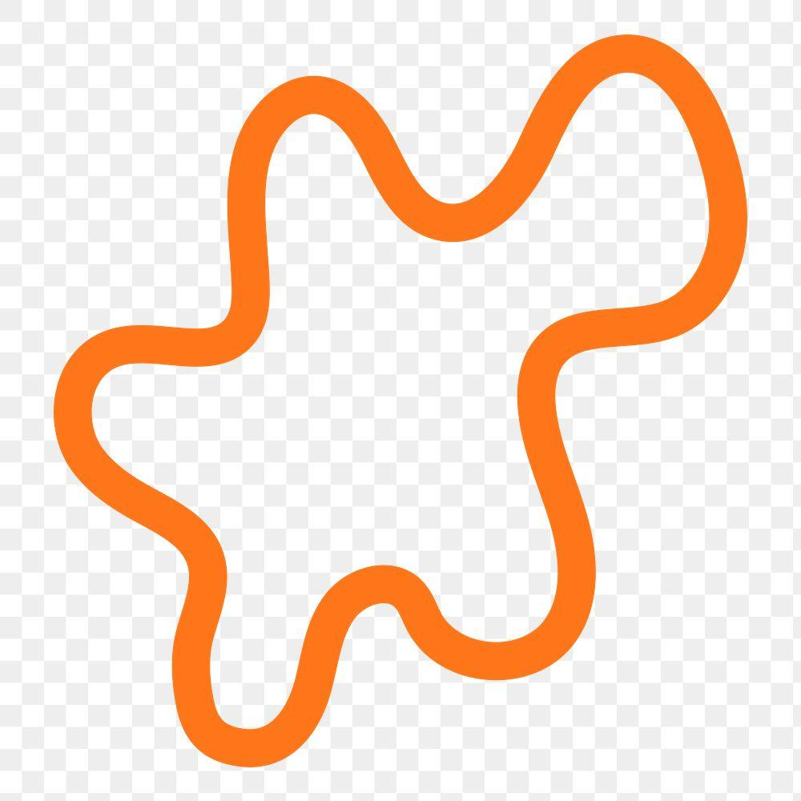

5-Irregular Freeform Wavy Shapes
# Source: AI Source: Provided by: [Data Path: Persons Table -> ID Column: 1, Name_En Column: Motasem Essam] -> From: [ChatGPT] on [7/25/2026]
An Irregular Freeform Wavy Shape has a highly variable curved boundary without a fixed repeating mathematical pattern.
It may contain:
- Large waves.
- Small waves.
- Gradual changes in curvature.
- Unequal spacing.
- Random-looking variations.
These shapes are common in natural and artistic forms.
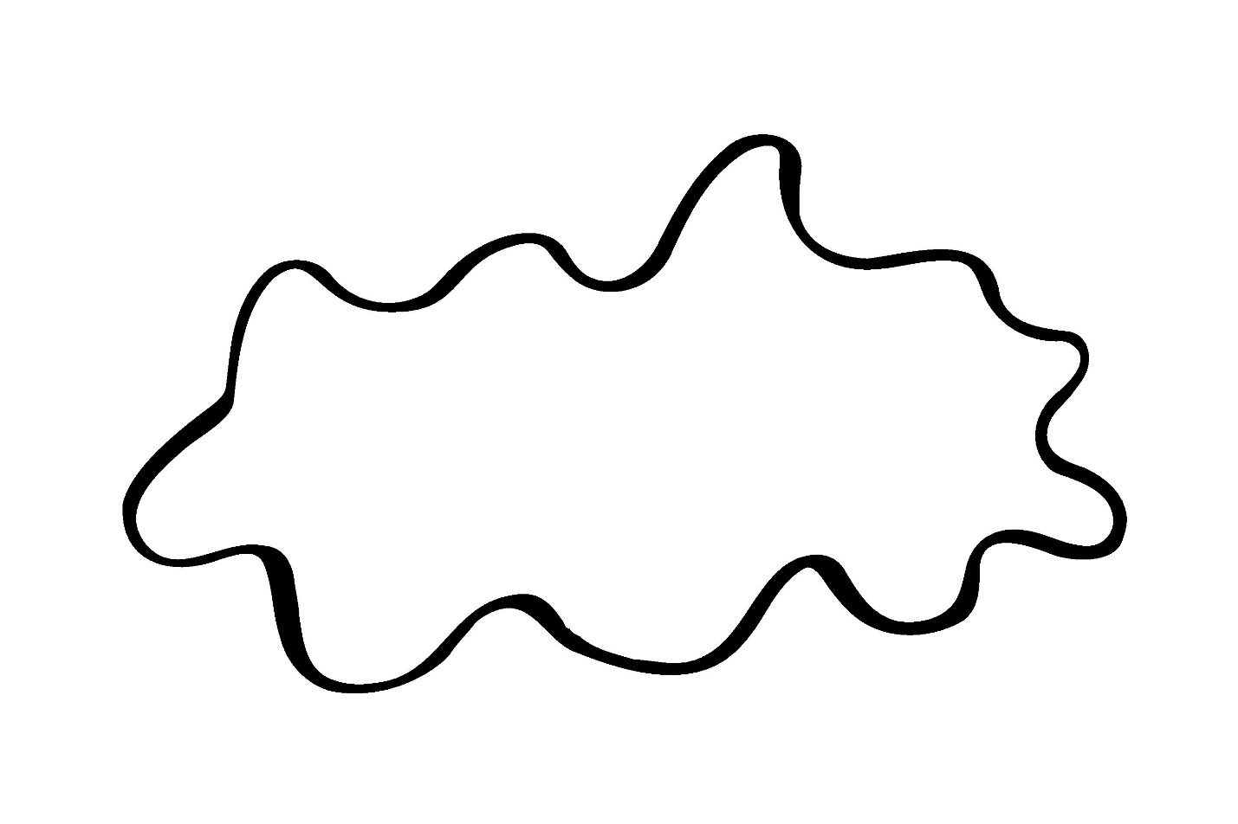
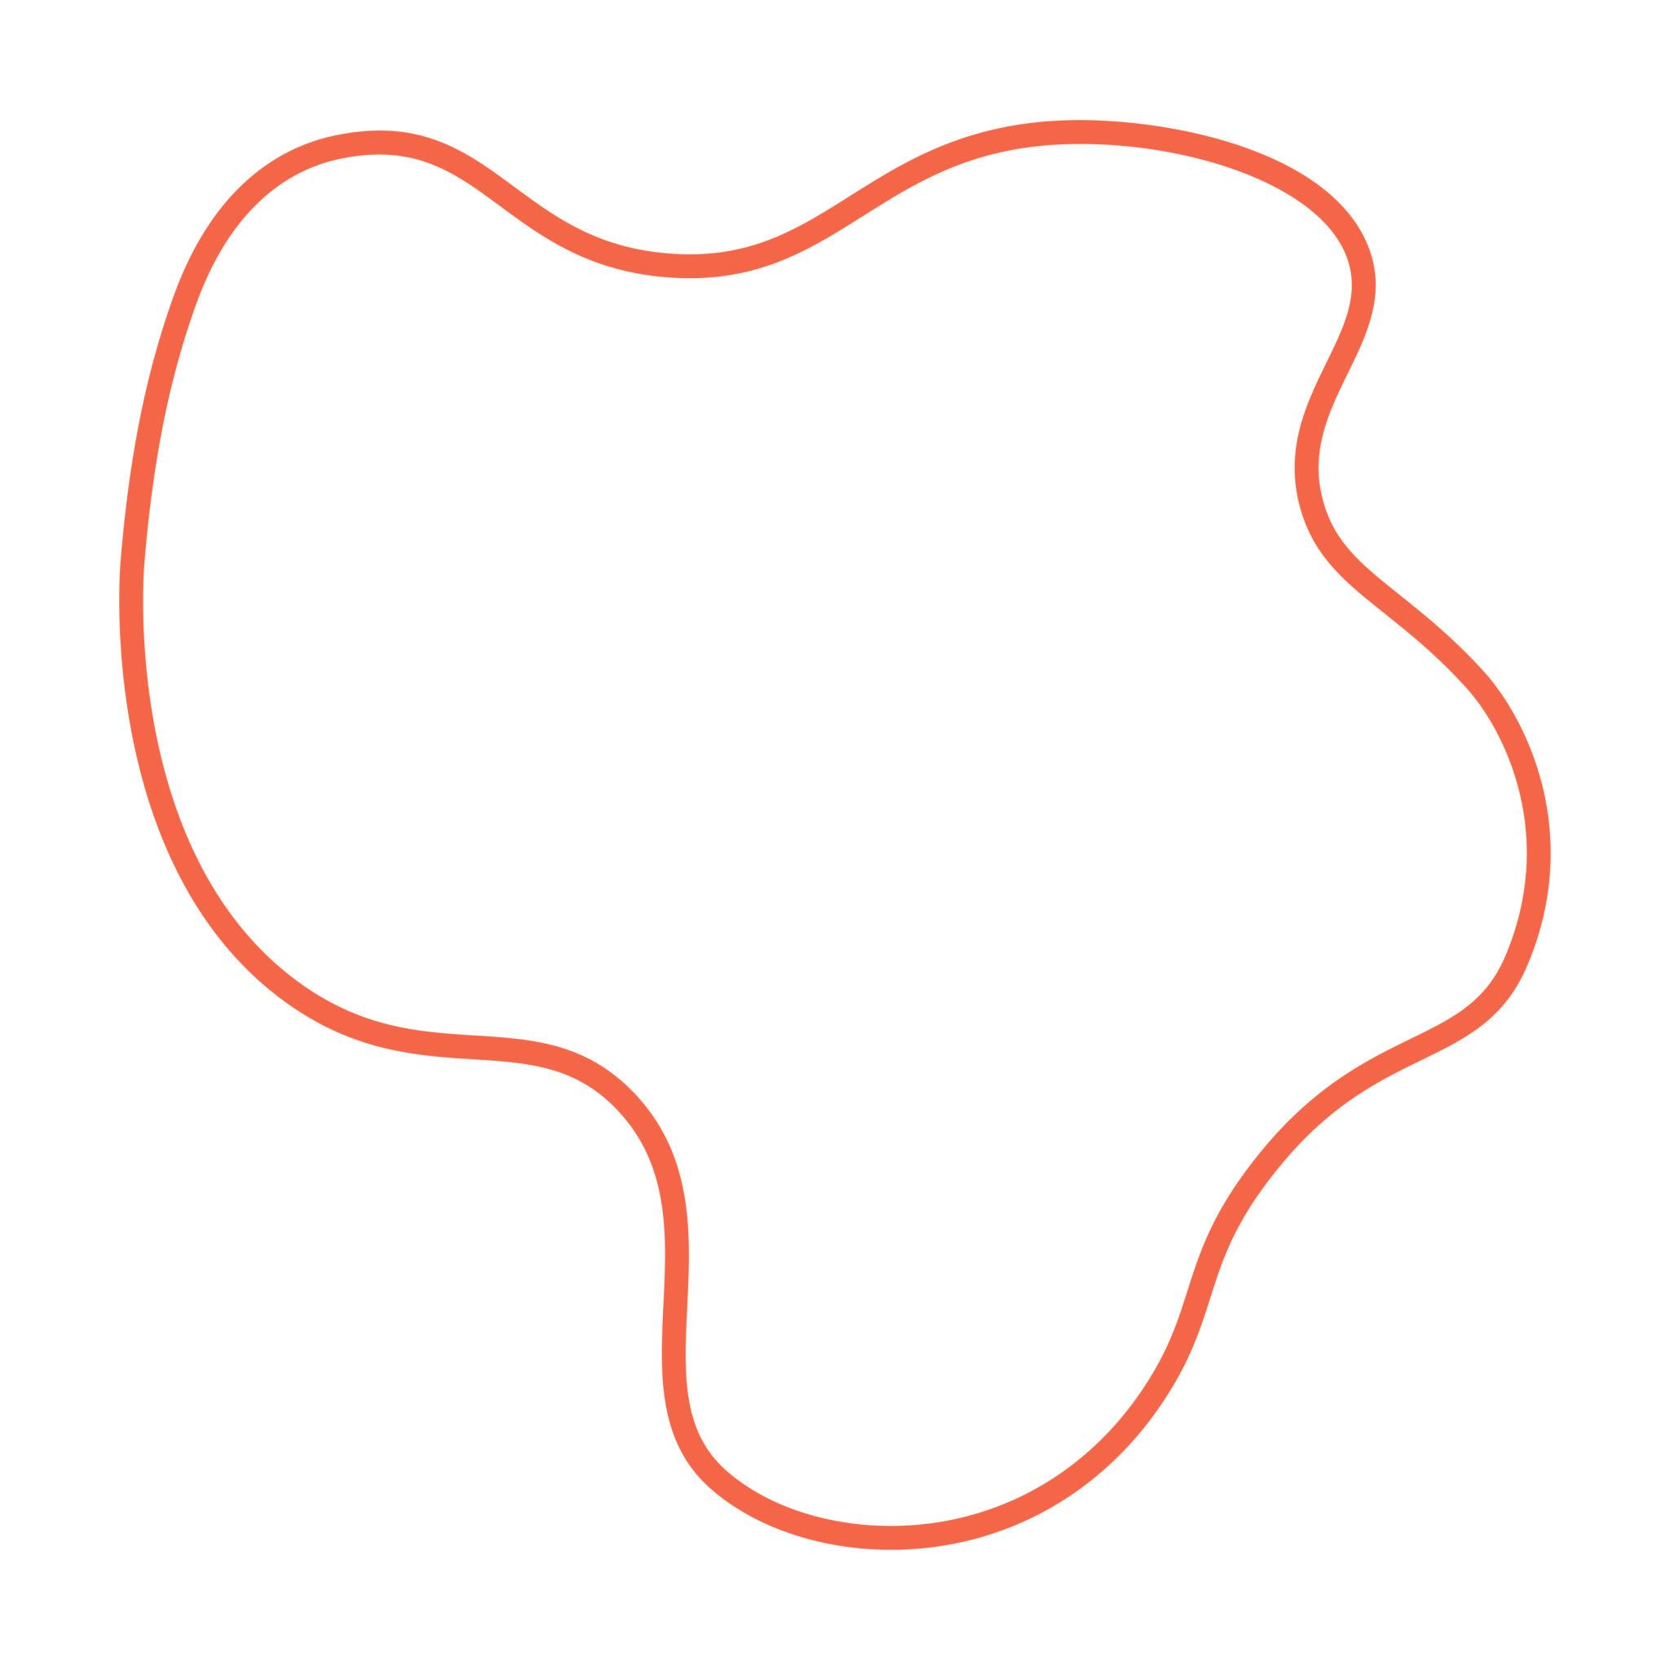
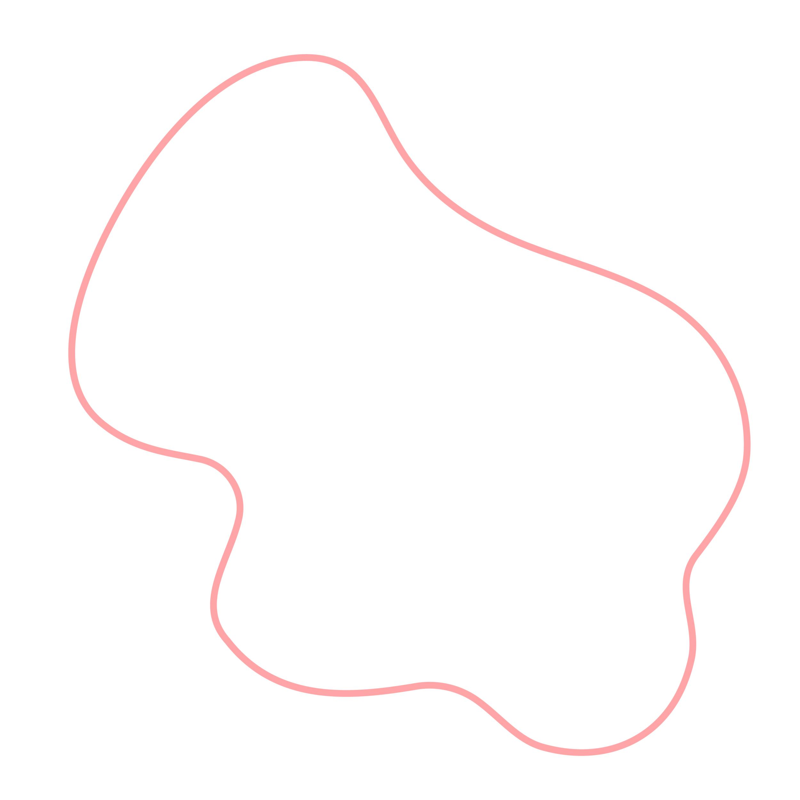
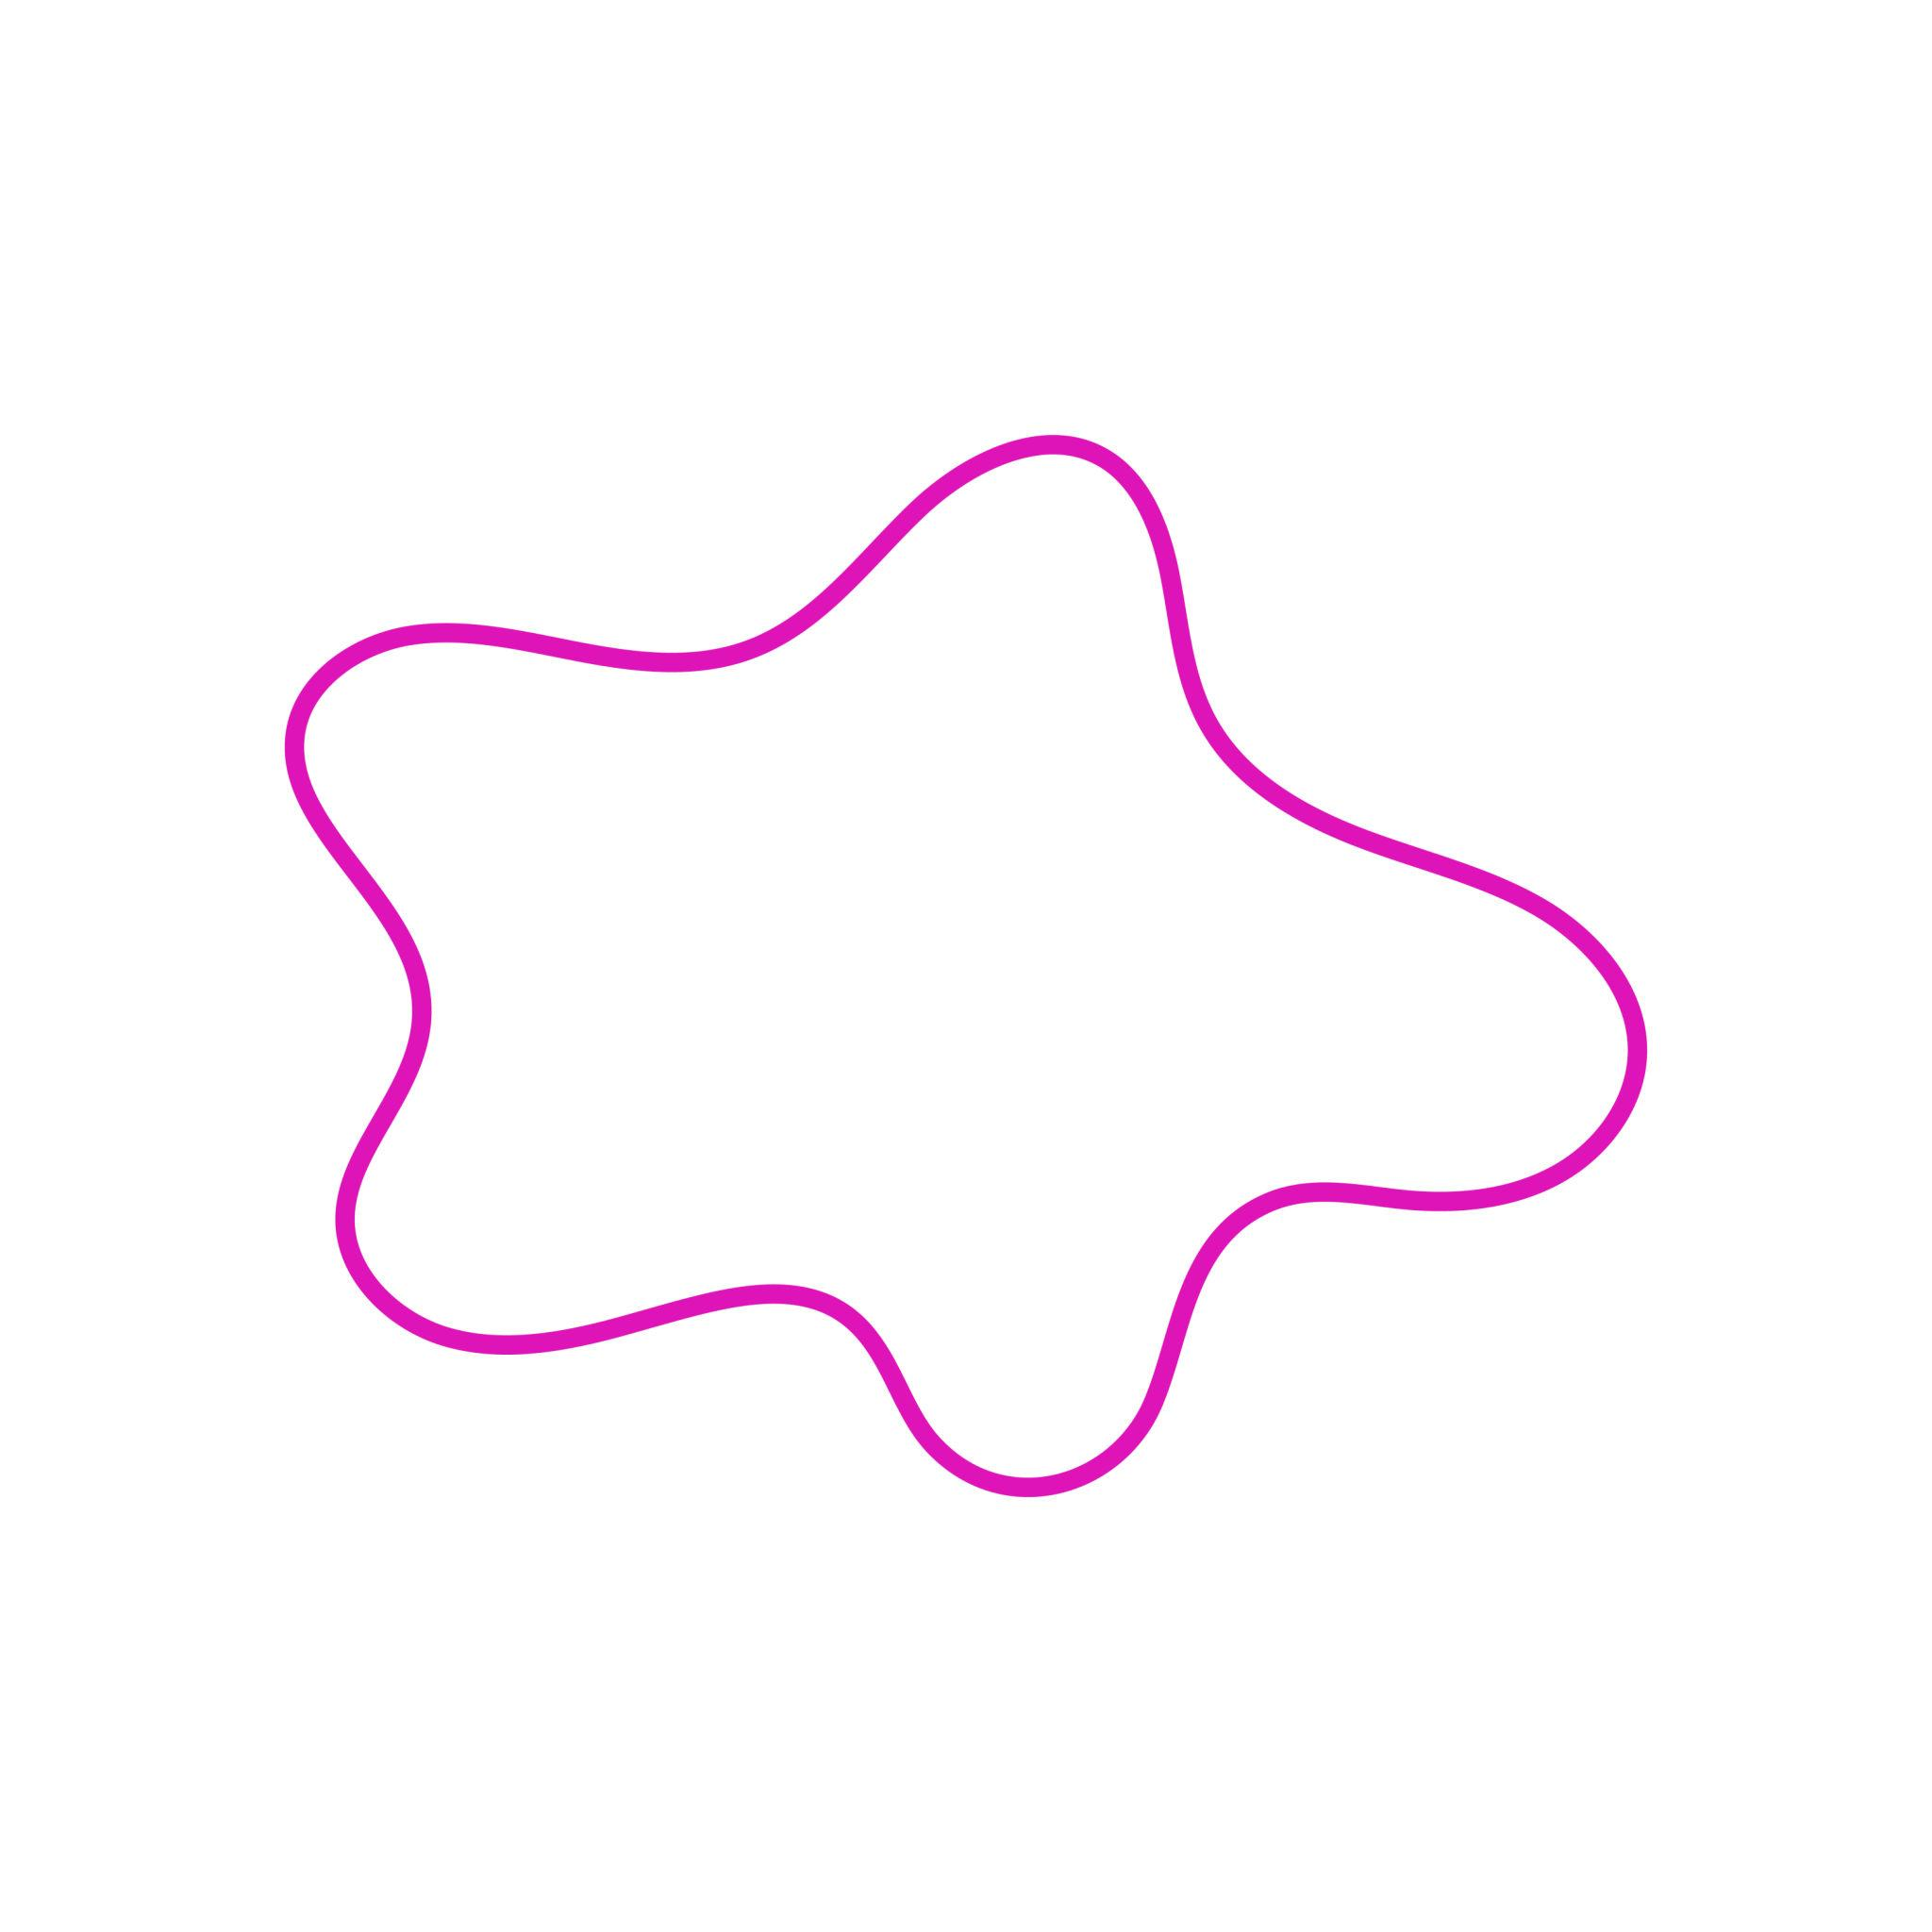

Mathematical Properties

Variable Amplitude
# Source: AI Source: Provided by: [Data Path: Persons Table -> ID Column: 1, Name_En Column: Motasem Essam] -> From: [ChatGPT] on [7/25/2026]
Unlike a simple sine wave with constant amplitude, an irregular wave can have an amplitude that changes with position.
A conceptual model is:
$$y=A\left(x\right)sin⁡\left(ϕ\left(x\right)\right)$$
where:
- $A\left(x\right)$= variable amplitude.
- $ϕ\left(x\right)$= variable phase.

Variable Frequency
# Source: AI Source: Provided by: [Data Path: Persons Table -> ID Column: 1, Name_En Column: Motasem Essam] -> From: [ChatGPT] on [7/25/2026]
The spacing between waves can change along the curve.
Instead of a constant frequency, the wave can have a changing frequency:
$$y=A\left(x\right)sin⁡\left(ϕ\left(x\right)\right)$$
where the rate of change of $ϕ\left(x\right)$varies with $x$.

Arc Length
# Source: AI Source: Provided by: [Data Path: Persons Table -> ID Column: 1, Name_En Column: Motasem Essam] -> From: [ChatGPT] on [7/25/2026]
For an open irregular curve represented by
$$y=f\left(x\right)$$
from $x=a$to $x=b$, its length is
$$L=\int_{a}^{b}{\sqrt{1+{\left(\frac{dy}{dx}\right)}^{2}}} dx$$
For a parametric curve:
$$L=\int_{a}^{b}{\sqrt{{\left(\frac{dx}{dt}\right)}^{2}+{\left(\frac{dy}{dt}\right)}^{2}}} dt$$

Enclosed Area
# Source: AI Source: Provided by: [Data Path: Persons Table -> ID Column: 1, Name_En Column: Motasem Essam] -> From: [ChatGPT] on [7/25/2026]
If the irregular wavy shape is closed, it encloses an area.
For a suitable closed parametric curve:
$$A=\frac{1}{2}\oint{(}\left.x dy-y dx\right)$$
Thus, irregularity does not prevent the calculation of area or boundary length.

Irregular vs Regular Wavy Shapes
# Source: AI Source: Provided by: [Data Path: Persons Table -> ID Column: 1, Name_En Column: Motasem Essam] -> From: [ChatGPT] on [7/25/2026]
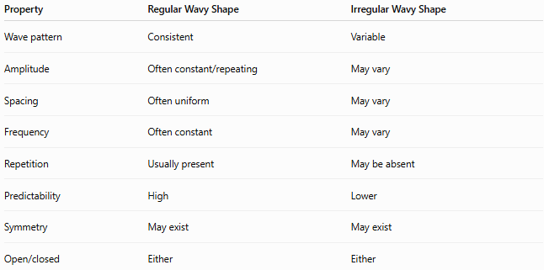
Property | Regular Wavy Shape | Irregular Wavy Shape
Wave pattern | Consistent | Variable
Amplitude | Often constant/repeating | May vary
Spacing | Often uniform | May vary
Frequency | Often constant | May vary
Repetition | Usually present | May be absent
Predictability | High | Lower
Symmetry | May exist | May exist
Open/closed | Either | Either
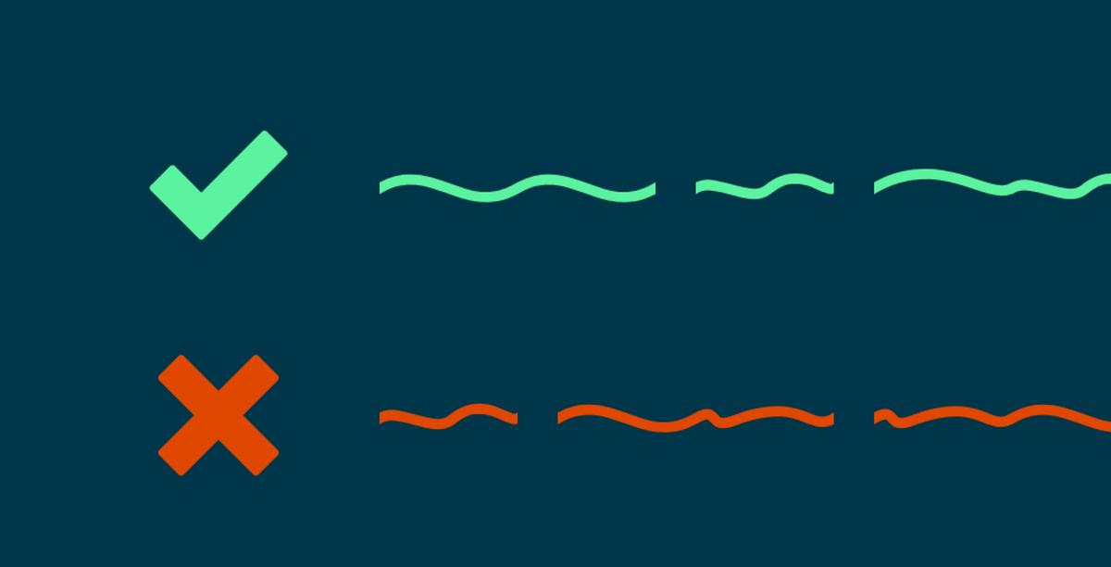
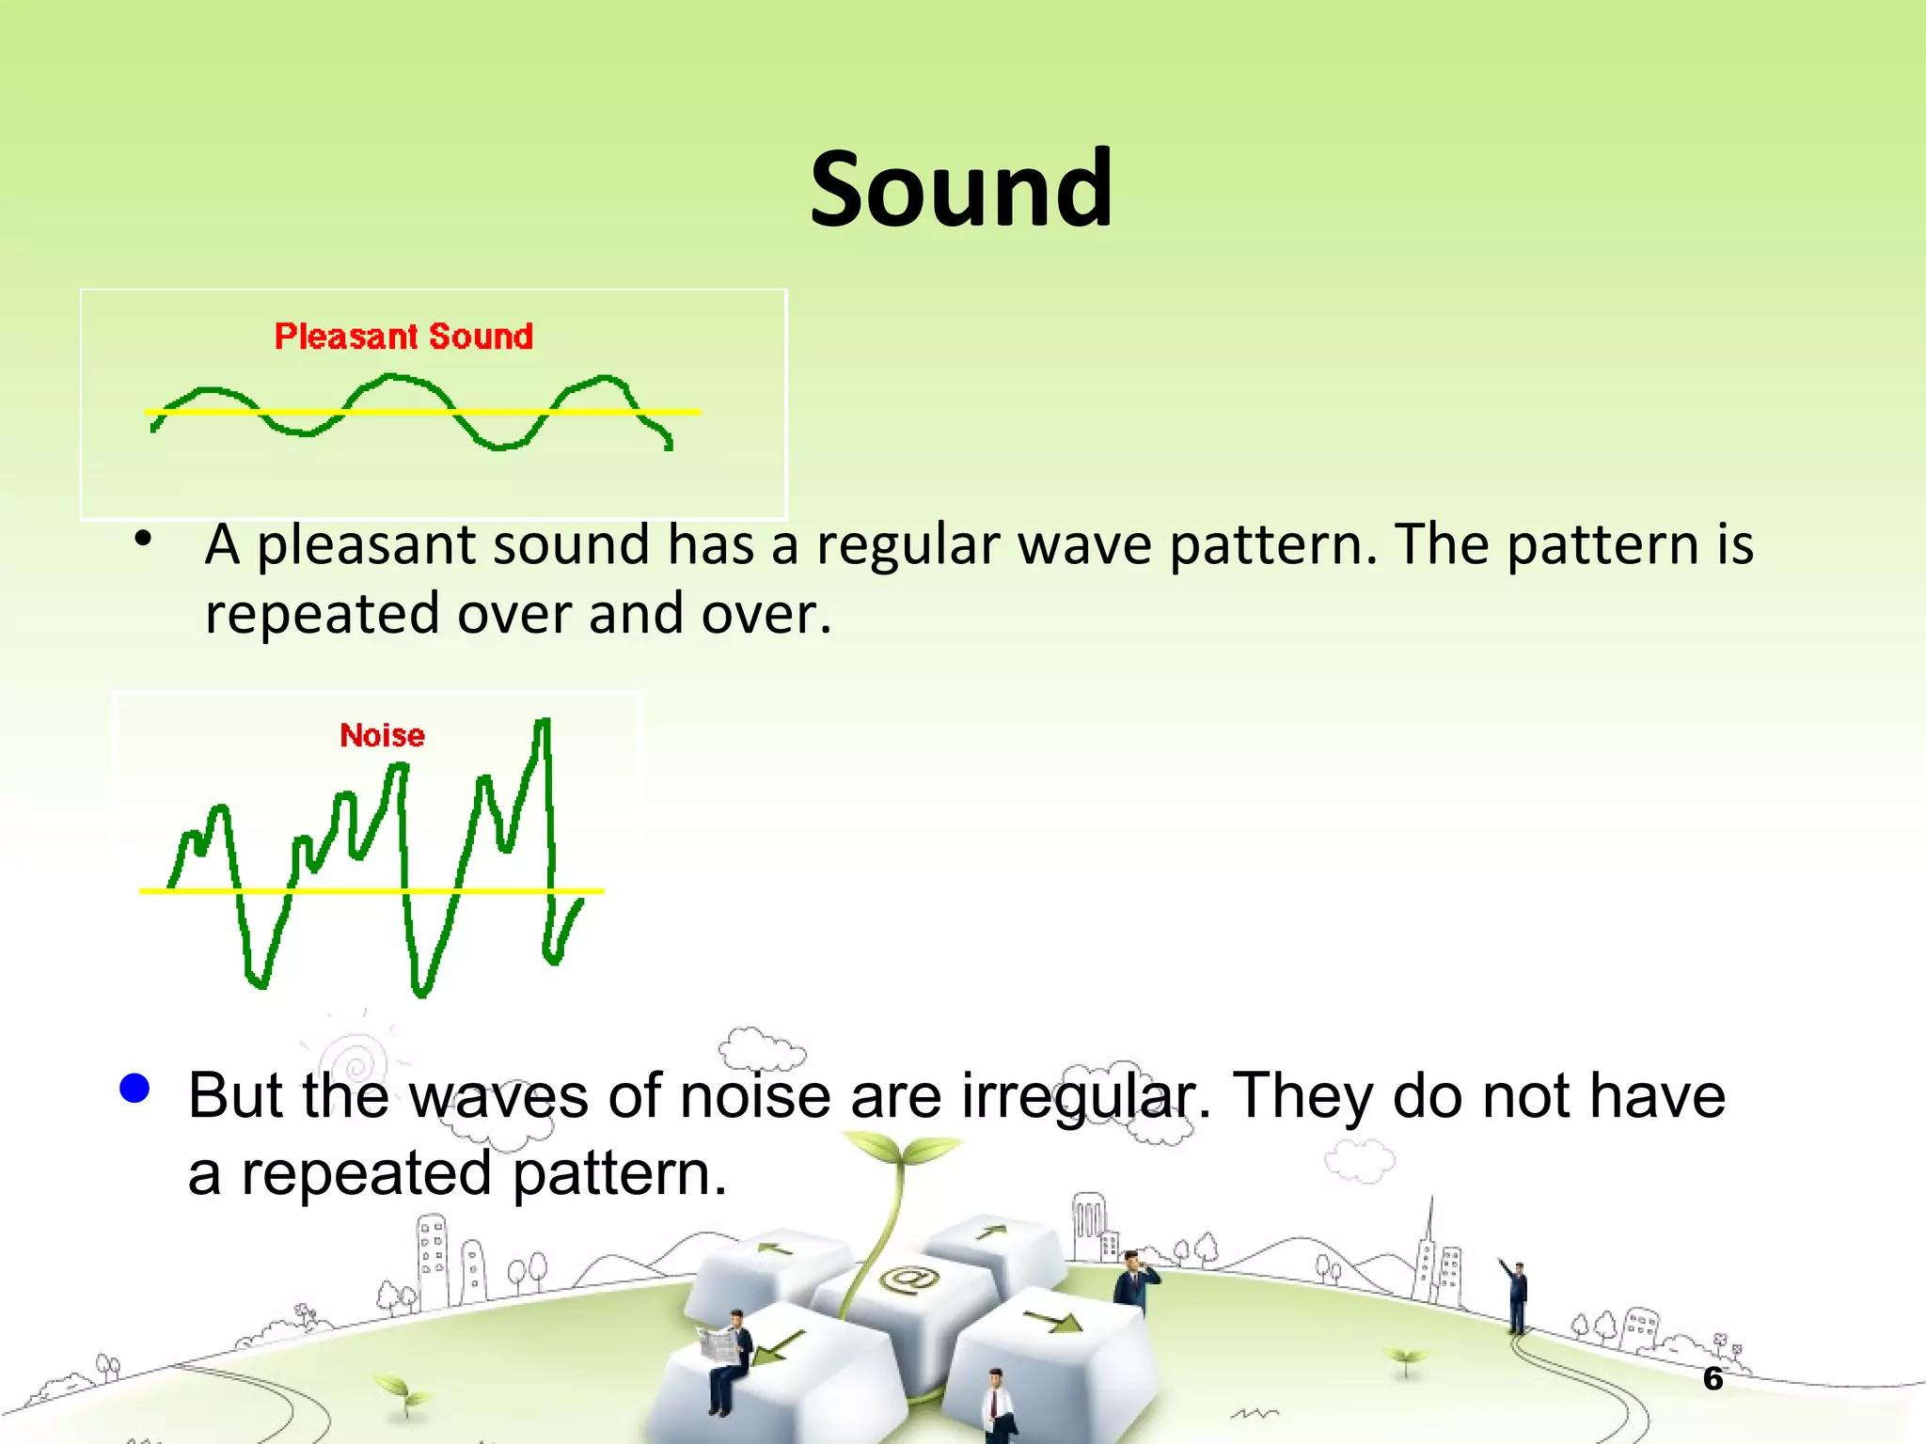
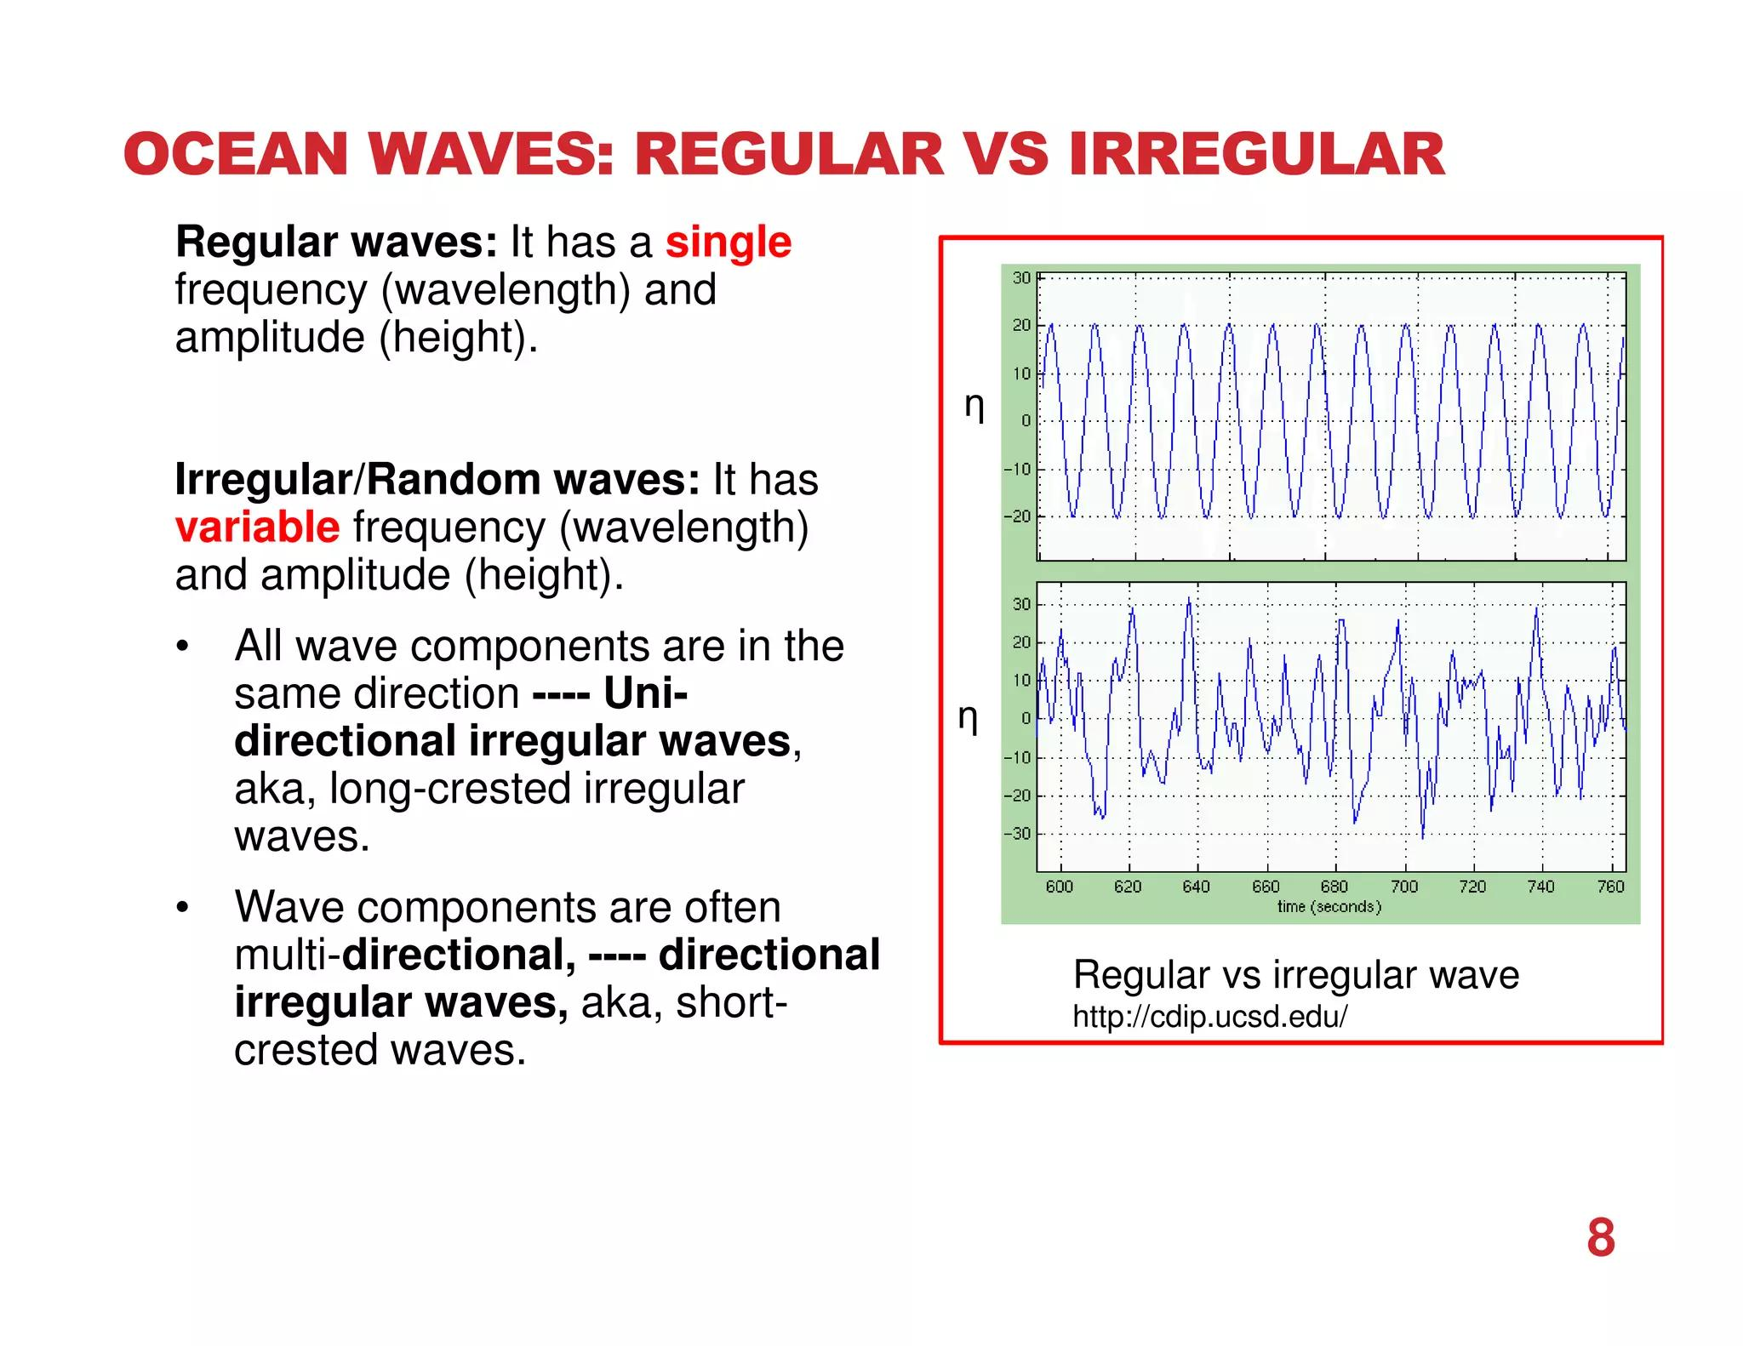

Irregular Wavy Shapes vs Asymmetric Wavy Shapes
# Source: AI Source: Provided by: [Data Path: Persons Table -> ID Column: 1, Name_En Column: Motasem Essam] -> From: [ChatGPT] on [7/25/2026]
These concepts should not be treated as synonyms.
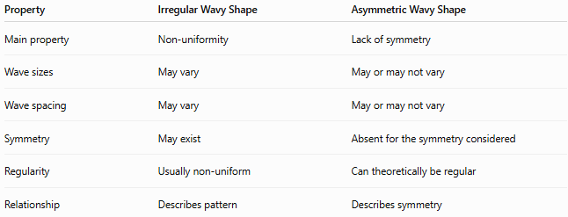
Property | Irregular Wavy Shape | Asymmetric Wavy Shape
Main property | Non-uniformity | Lack of symmetry
Wave sizes | May vary | May or may not vary
Wave spacing | May vary | May or may not vary
Symmetry | May exist | Absent for the symmetry considered
Regularity | Usually non-uniform | Can theoretically be regular
Relationship | Describes pattern | Describes symmetry
For example, a shape can be:
Irregular + Symmetric
or
Irregular + Asymmetric.

Examples
# Source: AI Source: Provided by: [Data Path: Persons Table -> ID Column: 1, Name_En Column: Motasem Essam] -> From: [ChatGPT] on [7/25/2026]
Examples of irregular wavy shapes include:
- A naturally occurring irregular wave boundary.
- A freeform organic outline.
- An irregular closed decorative shape.
- A curve with varying wave amplitudes.
- A curve with unequal wave spacing.
- An asymmetric freeform wave.
- A closed shape with different-sized smooth lobes.

Classification Summary
# Source: AI Source: Provided by: [Data Path: Persons Table -> ID Column: 1, Name_En Column: Motasem Essam] -> From: [ChatGPT] on [7/25/2026]
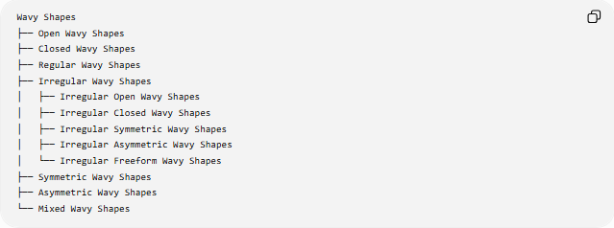
Wavy Shapes
├── Open Wavy Shapes
├── Closed Wavy Shapes
├── Regular Wavy Shapes
├── Irregular Wavy Shapes
│ ├── Irregular Open Wavy Shapes
│ ├── Irregular Closed Wavy Shapes
│ ├── Irregular Symmetric Wavy Shapes
│ ├── Irregular Asymmetric Wavy Shapes
│ └── Irregular Freeform Wavy Shapes
├── Symmetric Wavy Shapes
├── Asymmetric Wavy Shapes
└── Mixed Wavy Shapes
These categories overlap rather than forming mutually exclusive classes.
For example:
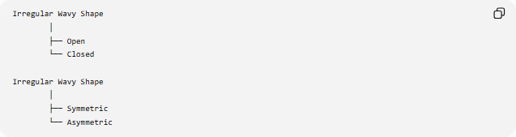
Irregular Wavy Shape
│
├── Open
└── Closed

Irregular Wavy Shape
│
├── Symmetric
└── Asymmetric
A single shape can therefore be an Irregular + Closed + Symmetric Wavy Shape.

Key Points
# Source: AI Source: Provided by: [Data Path: Persons Table -> ID Column: 1, Name_En Column: Motasem Essam] -> From: [ChatGPT] on [7/25/2026]
- An Irregular Wavy Shape has a non-uniform or non-repeating wave pattern.
- Its amplitude, spacing, curvature, or frequency may vary.
- It can be open or closed.
- It can be symmetric or asymmetric.
- Irregular ≠ asymmetric.
- A closed irregular wavy shape encloses a region.
- Irregular wavy curves can be represented using general or parametric functions.
- Their length and, when closed, their enclosed area can be calculated mathematically.

Conclusion
# Source: AI Source: Provided by: [Data Path: Persons Table -> ID Column: 1, Name_En Column: Motasem Essam] -> From: [ChatGPT] on [7/25/2026]
An Irregular Wavy Shape is a wavy form whose boundary lacks a uniform repeating pattern. Its waves may vary in size, spacing, curvature, or frequency, producing a non-uniform appearance. Irregularity describes the pattern of the shape, while properties such as open/closed and symmetric/asymmetric describe other independent characteristics.

